
phgy311
lecture #: | date: | professor:
15 | Oct. 16, 2006 | Dr. Haghighi
16 | Oct. 18, 2006 | Dr. Haghighi
announcements:
- Clothing froms deadline extended until October 25th, come get your forms from the PULS office
- Next Old Brewery Mission date is October 31st, sign up in the PULS lounge if you’re interested

Edited By: Steph Rolin
Do Not Redistribute
set #5
PHGY 311 - October 16th, 2006
Lecture 15 – Dr. Haghighi
Written by: Anne-Laure Morin

REVIEW
- Synaptic current is not the same as synaptic potential.
  - A synaptic current gives rise to change in potential.
  - A synaptic potential follows the synaptic current.
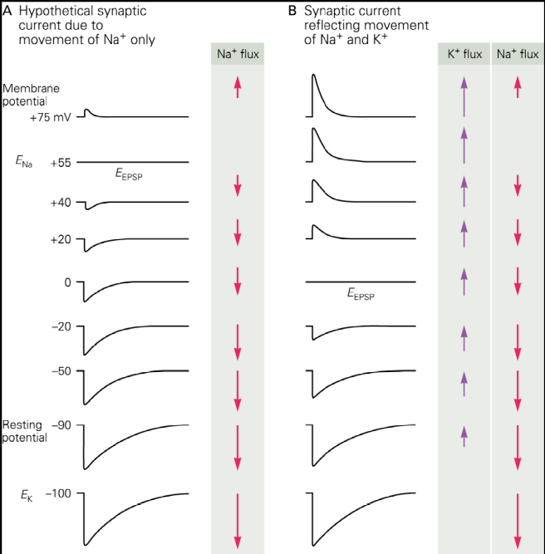
DIFFERENT ION CHANNELS
- If there are VGSCs present and you depolarize the membrane enough, past threshold, it will trigger an AP.
  - The same is true for VGPCs.

- These voltage-gated ion channels act independently of the ligand-gated channels.
  - However, ligand-channels provide the depolarization needed for these voltage-gated channels to open.

- The underlying ion currents of the AP don’t change, regardless of the presence of the ACh channels.
  - The currents would only change is Ena, Ek, and Ecl changed.

- The only thing difference in this scenario is that the opening of ACh channels provides the required depolarization to reach threshold.

REVERSAL POTENTIAL
- AChRs are non-selective, ligand-gated channels.
  - Ions flow through depending on their electrochemical gradients.

- Reversal potential is defined as the point where the ionic current reverses.
  - The place where the ionic current is 0.
  - Reversal potential of ACh-gated ion channels is determined by the flow of sodium and potassium.

- At reversal potential, we assume Vm = EEPSP
  - We can use this to solve for the ratio of conductances, similar to what we did in the previous section of this course.
  - Note that the reversal potential is the same for synaptic currents, synaptic potential, and single-channel currents.
    - They all reverse at the same membrane potential.
    - The underlying cause of the macroscopic current is the opening of single-channels.
- As usual, we know
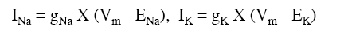
- Now, to solve for the reversal potential, we go through the following calculations. Make sure to use the values that are true at the reversal potential.
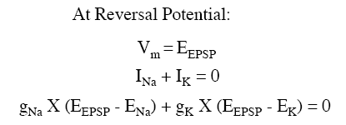
- So, we solve for the reversal potential and for the ratio of ion conductances.
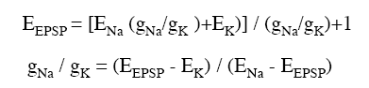

Relationship between synaptic potential, synaptic current and single channel current
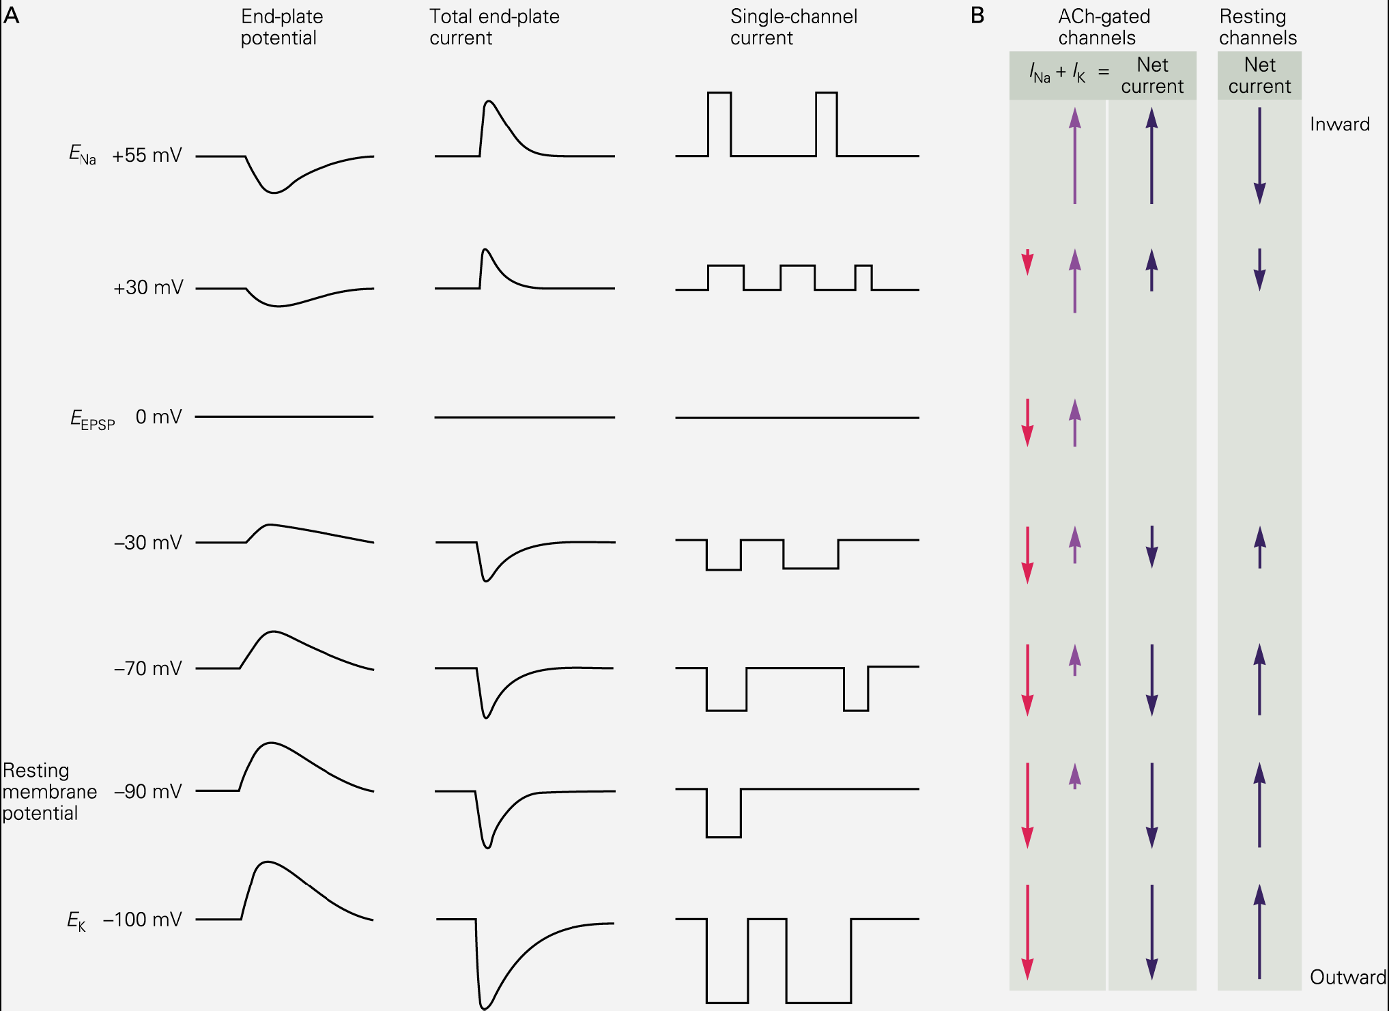
- Note that the end-plate potential, total end-plate current, and single-channel current all reverse at the same potential.
  - We are assuming it to be 0mV, although it changes based on the particular properties of a cell.
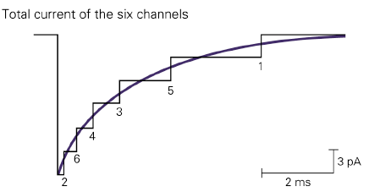
- The reason that individual channels reverse at the same potential is because the macroscopic current is a summation of these channels.
  - If you add up several single channels opening up at the same time, you get a current that resembles the macroscopic current we see when we record from the entire cell during an EPSP.

SAMPLE PROBLEMS
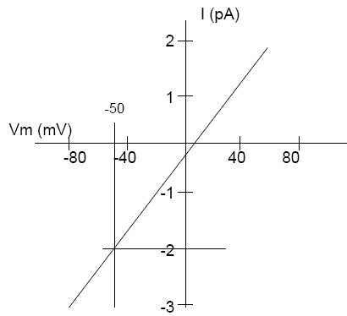
- The current-voltage graph on the right has been obtained from a single AChR at the NMJ.
- Notice that this graph is linear.
  - This means that conductance is constant.
- What is the reversal potential?
  - Reversal potential is where the current is 0, so from the graph we see that EACh = ~10mV
  - This depends on the ionic concentrations and the equilibrium potentials of sodium and potassium.
- What is the single channel conductance at -50mV?
  - Conductance is constant so you can use any 2 points on this graph to solve
  - So,
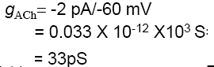
- What is the relative conductance of this channel to sodium and potassium, given that ENa = 50mV and EK = -100mV?
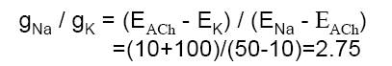

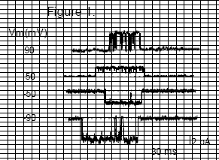
- Figure 1 shows single channel recordings from an ACh receptor on the postsynaptic muscle at a verterbrate NMJ.
- Normally, Vm is -65mV.
- Draw the I-V relationship:
  - For this question, you note the current at each membrane potential. These are your data points.
  - For example, at membrane potential of 90mV, the current is about 4 pA.
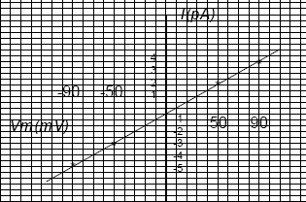

  - You have four points, plot this on a graph and you should get the graph on the left.

- What is the relative conductance of potassium to that of sodum at this NMJ, given that ENa = 50mV and EK = -100mV?
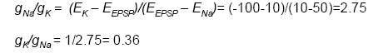

Rule of thumb to predict numbers:
- If reverse potential closer to Ek => GNa/Gk will be smaller
- If reverse potential closer to ENa =>GNa/Gk will be larger

Note : Conductance is never negative. It’s an absolute value regardless of direction of ion flow.
This is significant because when a membrane is leaky, it is leaky in both direction.

GLUTAMATE RECEPTORS
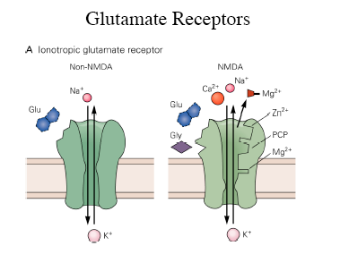
- There are two categories of flutamate receptors.
  - Ionotropic glutamate receptors
  - Metabotropic glutamate receptors
- Ionotropic GluRs are very similar to AChR.
  - Multi-subunit
  - They form a non-selective pore through which ions can flow.
  - Also ligand-gated, except by glutamate.
  - Excitatory synapse, as when the cell is at RMP, this synapse will cause depolarization.

- The behavior of the postsynaptic cell is very similar as it was wish AChRs.
  - Synaptic potential, synaptic current, and single channels reverse at the same potential.
  - Sodium and potassium flow according to their electrochemical gradients.
  - The activation of this channels causes depolarization.
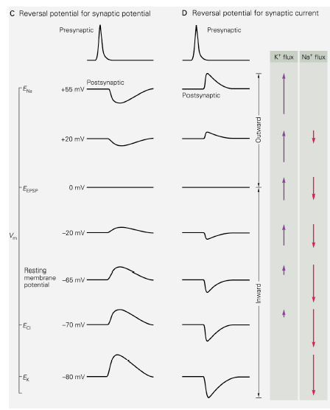
    - If depolarization is large enough, it can trigger an AP.

- Remember, if an AP is fired, it no longer has anything to do with glutamate.
  - Glutamate opens the receptors that give rise to the depolarization that will cause the AP.
    - AP is self-generating.
  - The ionic currents underlying the AP are unchanged.

MACROSCOPIC CURRENT
- As with AChRS, we can model the macroscopic current by looking at single channel currents.

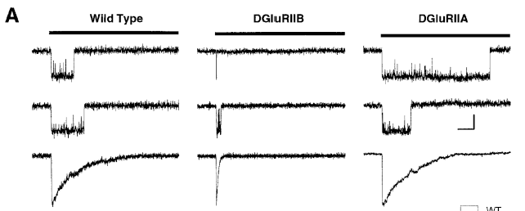

- Here, we are looking at a GluR, and two mutated versions of it.
  - Wild type is the normal channel.
  - DGluRIIB is missing RIIA.
  - DGluRIIA is missing RIIB..
- We do the same experiment and try to model the macroscopic currents based on single-channel currents.
- It is obvious that DGluRIIB is open for a much shorter period of time.
  - Reaches same peak of current as the other two types, but it opens and closes very quickly in comparison.
- So, looking only at the peak of current will not tell you everything. In this case, the amplitude of DGluRIIB is the same as the other two, but the kinetics have changed.
  - The amplitude may be the same, but recall that it takes time for the capacitor to charge up. So in order to have a synaptic potential, we need to have a lasting current.
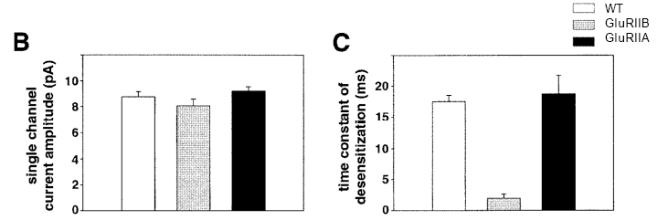
- Membrane depolarization will be different, if the single channel is open for a different amount of time.
  - The longer the current lasts, the more charges will move in and out of the membrane.

IONOTROPIC GLUTAMATE RECEPTORS
- These receptors can be subdivided into non-NMDA and NMDA.
  - NMDA receptors have slow conductance, but play a major role in allowing calcium to enter the cell.
  - Non-NMDA receptors are often referred to as AMPA receptors. They are not as permeable to calcium.

- NMDA receptors are normally blocked at negative membrane potentials by magnesium.
  - They don’t really open at physiological concentrations of magnesium.
- So normally, these channels are almost silent at negative potentials.

- When glutamate enters the synapse, NMDA receptors exhibit no response. The depolarizing response that we see is due to AMPA receptors. AMPA receptors are not blocked by magnesium, so when they bind glutamate, they open and allow ions to flow.
  - This causes the membrane to depolarize.
- Depolarization of the membrane removes the magnesium block, so now the NMDA can contribute to the ionic current.

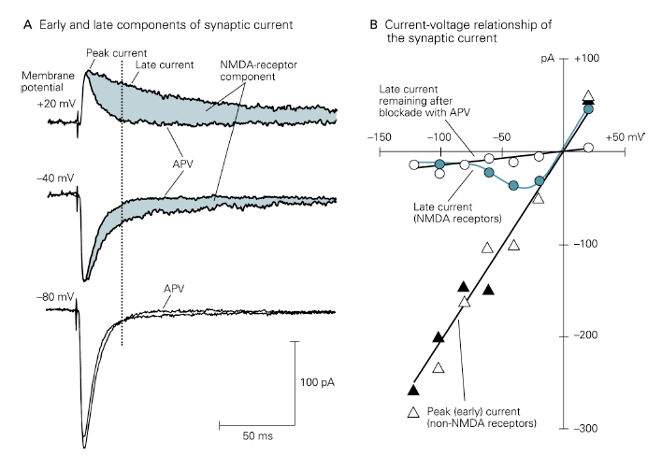
- So when we look at graphs of the current, we see two pieces.
  - There is an early current, due to the AMPA receptors.
    - This is a fast peak, corresponding to the AMPA contribution.
  - We see a late, lasting current.
    - This is the NMDA-receptor component.

Last thing Dr Hagighi talked about:
- Increase in [Ca] inside the cell usually causes release of neurotransmitter
- New records show: we can also use AMPA type glutamate receptor to substitute for Ca voltage gated channels to allow Ca to come in and cause neurotransmitter release.
- Important concept b/c it is another means to bring Ca within the cell.

PHGY 311 – October 18th, 2006
Lecture 16 – Dr. Haghighi
Writer: Michelle Laneuville

PLEASE NOTE: This lecture is UNEDITED
The edited version will be available in the next NTC set

Excitatory VS Inhibitory Receptor

The only way to determine if a response is excitatory or inhibitory is by referring to the resting membrane potential.
- Excitatory responses (EPSP) will depolarize the cell (Ex: -65 mV to –55 mV).
- Inhibitory responses (IPSP) will hyperpolarize it (Ex: -65 mV to –70 mV).
- If there is both an excitatory and inhibitory response at the same time, you need to look at the net effect of the receptors (Ex: +10 mV – 5 mV = + 5 mV depolarization).

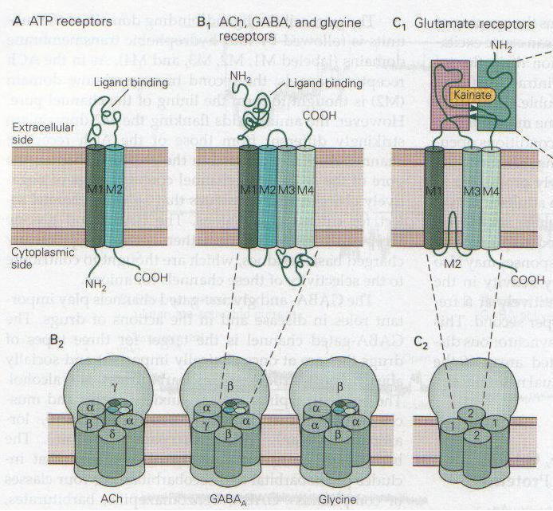
- Acetylcholine and glutamate receptors are multimeric receptors (many subunits).

Structurally divided into 3 groups:
- ATP receptors
- ACh, GABA and glycine receptors
- Glutamate receptors

What they all have in common:
- They are neurotransmitter gated.
- They cause fast synaptic currents.

The best way to define if a receptor is excitatory or inhibitory is by looking at the direction of the current through voltage-clamp experiments.
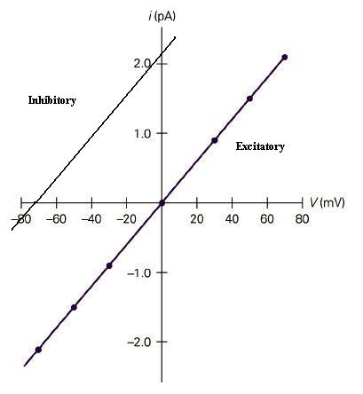
- Excitatory receptors have current flowing into the cell (depolarization).
- The resting membrane potential is more negative than the reversal potential, so their driving force is negative and it causes a negative current.
- Convention: negative current = inward current (positive ions flow in (Na⁺, Ca²⁺), negative ions flow out).

- Inhibitory receptors have current flowing out of the cell (hyperpolarization).
- Their resting membrane potential is more positive than the reversal potential, so their driving force is positive and it causes a positive current.
- Convention: positive current = outward current (positive ions flow out (K⁺), negative ions flow in (Cl⁻)).
- These receptors are usually glycine or GABA receptors.
- If the cell is hyperpolarized so that Vm is more negative than the reversal potential, the current will become inward and the receptor will depolarize the cell.

- When looking at a Vm vs I curve, inhibitory receptors are to the left of the excitatory receptors. So if Vm = -60 mV, we clearly see that the inhibitory receptor has a positive current (hypolarization) and the excitatory receptor has a negative current (depolarization).
- Synaptic potentials reverse at the same place as synaptic currents reverse, because the current is the underlying reason for the change in membrane potential.

- You won’t be asked what GABA receptor selects for or which family a receptor is part of. You will usually be given experimental data and you’ll have to analyze it to determine if it’s excitatory or inhibitory.

Glycine Receptor

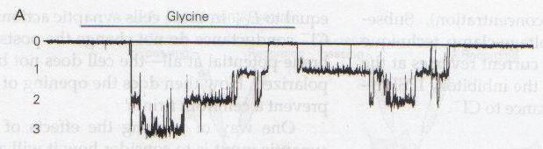
- You can see the glycine receptors opening at different time intervals. In the first pulse, 2 receptors open at the same time, and a 3rd one a bit later.
- They stay open for a while, then you can see a stepwise closing of the receptors (1st one closes, 2nd one closes, then all are closed).

- Glycine is an inhibitory receptor, but on the graph, the current is inward because the cell was hyperpolarized (Vm is more negative than the reversal potential of ~ -70mV). They do this because it’s easier to hyperpolarize a cell and keep Vm negative than it is to depolarize it and keep Vm at a positive value.

- All receptors could be excitatory or inhibitory to some point, depending on how much you hyperpolarize or depolarize the cell membrane compared to the receptor’s reversal potential.
- The longer a receptor is open, the more charge is accumulated on the membrane (ΔQ) and the more the membrane potential will change.

- Example of different reversal potentials: GABA (inhibitory) = -60 mV VS glutamate (excitatory) = 0 mV.

Quantal Analysis

- Each vesicle has a quantal amount of neurotransmitters (fixed amount that doesn’t change). Thus when vesicles are released, changes in the postsynaptic potential are in increments of quantal units.

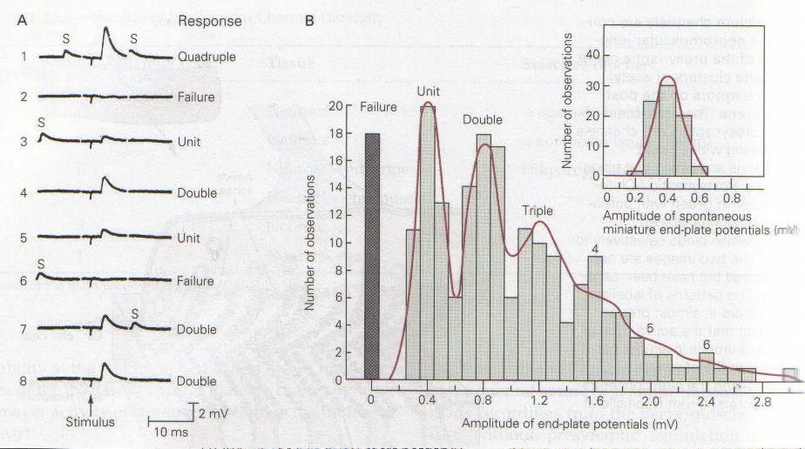
Failure analysis: Named this way because it fails many times. It is not a voltage-clamp experiment. Low [Ca²⁺] and high [Mg²⁺] are maintained to lower the chances of neurotransmitter release (if there’s too many neurotransmitters, you can’t measure the individual quantal unit because the potential change would be too high). They evoke activity then measure the change in potential from the resting membrane potential (fig. A).

- Each little blip is when a (some) vesicle(s) is(are) released. Each one causes a small depolarization in the postsynaptic membrane (MEPSP).
- In a muscle cell, one small depolarization is not usually enough to cause a muscle to contract.
- The sum of all the MEPSPs is the Excitatory Postsynaptic Potential (EPSP).
- The sum of all the MEPSCs (small current) is the Excitatory Postsynaptic Current (EPSC).

- They transfer this data into a binomial distribution (fig. B). Each peak is the amount of units of quanta released. As you can see, the MEPSP is 0.4 mV and increases according to n x 0.4 mV, where n = number of vesicles released).

Quantal size in every synapse is the amount of current (MEPSC) or potential change (MEPSP) in the postsynaptic cell in response to the release of neurotransmitters by one vesicle.
- Does not change in response to changes in [Ca²⁺], because the release of neurotransmitters from vesicles is due to passive fusion (no presynaptic activity).
- Stays constant under normal physiological conditions.
- Measured by postsynaptic potential/current change to determine the presynaptic response. In this process, there can be things that interfere with the measurements, such as 2 vesicles fusing at the time, making the quantal size seem larger than it actually is. If you measure the quantal size multiple times, the average should remain constant.

Question: If one quantum is released and every vesicles has 7000 acetylcholine molecules, how many acetylcholine receptors will be activated?

- 7000 receptors
- 3500 receptors
- 1300 receptors

Answer: The answer is B only if the efficiency is 100%, which never happens in real life. Thus the answer is C, and only 2600 ACh molecules will bind to a receptor (other molecules diffuse away or are hydrolysed).

Quantal content (m)= the sum of all neurotransmitters released (all vesicles).
- It is Ca²⁺ dependent, because fusion of vesicles with the membrane needs an evoked signal (not passive).
- m = mean EPSP/ mean MEPSP
- Failure analysis: Number of trials and the number of failures will give you idea of quantal content.

PHGY 311 – Lecture16
October 18, 2006 – Dr. Haghighi
Writer: Steph Rolin
Note: The ntc above is unedited. This is our editor’s version of the same lecture.

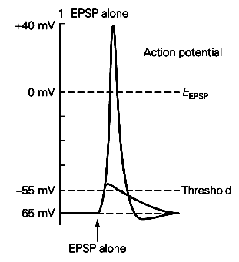
EXCITATORY AND INHIBITORY RECEPTORS
- An excitatory receptor causes depolarization from rest when open.
  - If a synaptic current causes depolarization, it’s an excitatory synapse.

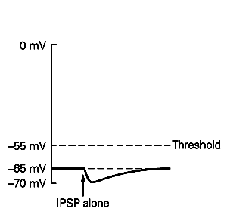

- An inhibitory receptor causes hyperpolarization when open.
  - If a synapse hyperpolarizes the cell, it’s an inhibitory synapse.

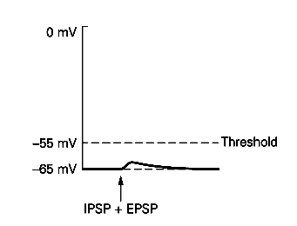
- If there are simultaneous EPSPs and IPSPs, they work against each other, and nothing much happens.
  - So excitatory and inhibitory synapses can affect each other, and we look at the net effect.

LIGAND-GATED ION CHANNELS
- Structurally, we divide ligand-gated ion channels into 3 categories.
  - ATP receptors
  - ACh, GABA, and glycine receptors
  - Glutamate receptors
- They channels are all similar because they are neurotransmitter-gated and they cause fast synaptic currents.

- ATPR, AChR, and GluR are excitatory receptors.
  - They cause depolarization at normal RMP.
  - Their reversal potentials are above the RMP.
- Excitatory synapses use excitatory neurotransmitters and excitatory receptors.
  - Give rise to an inward or negative current, usually carried by cations, at RMP.
- GABA and glycine receptors are inhibitory receptors.
  - Their reversal potential is more negative than at rest.
  - At RMP, they give rise to an outward or positive current.
    - This current is carried by K+ and Cl-.

INHIBITORY POSTSYNAPTIC POTENTIALS (IPSPs)
- These are mediated by GABA or glycine receptors.
  - The reversal potential is less than the RMP.
- Outward current through chloride selective ion channels underlies the IPSP.
  - Both GABA and glycine receptors allow chloride to flow into the cell.
    - This is an outward or positive current, as chloride is an anion.
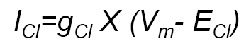
- GABA (B) receptors also involve the outward flow of potassium ions.
  - Positive current.
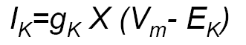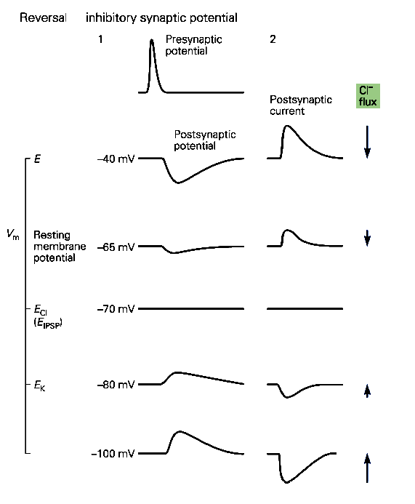
  - Note on this picture that above -70mV, currents are hyperpolarizing, currents at voltages below -70mV are depolarizing.
    - -70mV is the reversal potential.
  - Also, the postsynaptic potential and postsynaptic current reverse at the same voltage.

SINGLE-CHANNEL RECORDINGS
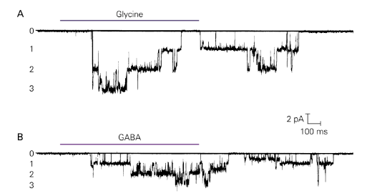
- Synaptic potentials and currents correspond to single-channel openings.
- In this experiment, a cell was being held at different voltages.
  - We are pushing single channels to open, and seeing in which direction the current is flowing.

- In the picture, the GABA and glycine receptors are giving rise to a negative current. Since these are inhibitory channels and give rise to an outward/positive current at the RMP, we know the cell must be being held at a negative membrane potential.

- The longer channels are open, the more charges that can cross into or out of the cell.
  - What happens to the IPSP if we decrease the number of glycine channels by half?

- Note: The reversal potential for GABA receptors is -60mV, but the reversal potential for GluR is 0mV.
  - This is because GABA Rs are inhibitory, while GluRs are excitatory.

QUANTAL ANALYSIS
- Neurotransmitters are released in vesicles.
  - This is different from other secretions, like hormonal secretions which are released gradually, over time.
- Neurotransmitters are released in vesicles, and each vesicle contains a quantum of neurotransmitter.
  - So you get quantal changes, not a continuous range of currents.
- We usually assume that every vesicle has the same amount of neurotransmitter.
  - Blips correspond to individual vesicles being released.
- If you stimulate an axon enough, you’ll get an EPSP.
  - Many MEPSPs at the same time sum together to form an EPSP.

FAILURE ANALYSIS
- Neurotransmitter is released in fixed increments, or quanta, and their probability of release can be described by a Poisson distribution.
- You perform a failure analysis to determine what the Poisson distribution is.
  - Performed under very tight conditions. We are performing a detailed analysis to see the relationship of Nt release to concentrations.

- If we lower calcium concentrations and increase magnesium concentrations (magnesium blocks calcium channels!), we suppress Nt release.
  - We stimulate presynaptic terminal and record from postsynaptic membrane.
- If we didn’t perform this experiment under such tight conditions, we would just get a huge increase every single time.

QUANTAL SIZE
- Miniature endplate potentials (MEPPs) or miniature excitatory postsynaptic potentials (MEPSPs) are the result of opening of postsynaptic receptors in response to the passive fusion of Nt release.
  - Average amplitude of MEPSP is referred to as quantal size.
- Quantal size corresponds to the amount of potential change in response to the release of 1 vesicle. It is in clear, distinguishable peaks.
  - Basically the change in potential of the postsynaptic cell in response to the fusion of a single vesicle.

- Quantal size is:
  - Is independent of extracellular calcium levels.
    - This is a passive fusion of Nt vesicles. It doesn’t require calcium, as vesicles spontaneously fuse.
    - Does not require presynaptic AP or activity. It is miniature, spontaneous, and calcium independent.
  - Tends to remain constant under a variety of physiological conditions.
    - For the most part.
  - Can appear to be larger in some cases due to the simultaneous fusion of two or more vesicles.
    - If the quantal size does appear increases, this does not mean it has changed. The average will be unchanged; it’s probably due to the simultaneous fusion of 2 separate vesicles.
  - Can change if the sensitivity or number of postsynaptic receptors is significantly altered.
    - Changing the number of postsynaptic receptors will appear as if the quantal size has changed—which it has.

QUANTAL CONTENT
- Quantal content (m) is referred to the number of vesicles that are released per one stimulation at the synapse.
- It can me measured in 2 ways:
  - Quantal content = m = (Mean EPSP) / (Mean MEPSP)
    - Need to know synaptic potential and divide by amplitude of MEPSP.
    - Determines how many vesicles were released.
  - Quantal content = m = ln [ N / n* ]
    - N = number of trials
    - N* = number of failures

- Quantal content is calcium dependent.
  - This is calcium-triggered vesicle release.
- Quantal content is not constant—it varies.
  - Anything that disrupts calcium or the release process can affect quantal content.
  - Think failure analysis—this changed if we changed the calcium concentration.

